Ocean Currents.
Interpreting a map of ocean currents.
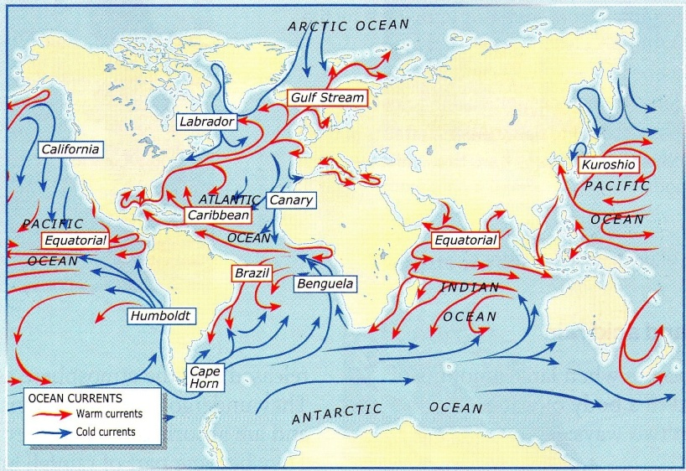
NOTE: Ocean currents are large masses of water, similar to rivers. They circulate through oceans and influence the climate of coasts.
GUESS! Circle the correct information.
In a warm current, the temperature is higher/lower than in the water around it.
In a cold current, the temperature is higher/lower than in the water around it.

Activities:
Ex. 1. Look at the map and circle the correct information.
- The map is about: a. the world’s rivers b. ocean currents
- The blue arrows ( ) represent: a. warm currents b. cold currents
- The red arrows represent: a. warm currents b. cold currents
- Warm currents start: a. near the equator b. near the poles
- Cold currents start: a. near the equator b. near the poles
- The starting point of water determines the current’s temperature: a. yes b. no
Ex. 2. Follow the instructions.
- Colour the Gulf Stream in yellow.
- Write correct sentences taking words from the substitution table.
The Gulf Stream  The Canary Current | makes temperature | go up  go down | because it starts | near the pole. near the equator.

The Gulf Stream .............................................................................................................................................................
...............................................................................................................................................................................................The Canary Current ........................................................................................................................................................
...............................................................................................................................................................................................

